Ruh.ai V1 Reference Pack Definition
AI BuildOps Pack
  - Governed digital employees for intake, specification, implementation planning, build orchestration, evaluation, release, and post-release learning
This document defines the first horizontal reference pack for companies that build AI products. It instantiates the platform PRD and pack specification as a reusable operating pack that turns software delivery into a governed conveyor of digital employees instead of a chain of manual handoffs.
What this pack must accomplish  Normalize messy inbound product, support, and incident signals into clean work items.  Generate better specifications and plans before work is assigned to coding agents or engineers.  Use digital employees to orchestrate build, eval, review, release, and post-release learning without removing human control from architecture or production.  Stay horizontal across AI product companies by focusing on common SDLC workflows rather than one team's exact stack. | Document facts  Pack ID: ref.ai.buildops  Reference version: 1.0.0  Pack type: Function reference pack  Primary deployment model: One tenant trust boundary; one workspace per product or repo cluster  Conforms to: Ruh.ai V1 Employee Pack Specification

Outcome area | Problems removed | Primary workflows | Business measures
Work intake | Requests arrive through support threads, Slack, incidents, and product notes with poor deduplication or prioritization. | Signal intake and triage | Backlog hygiene, time-to-owner
Specification quality | Teams start coding from partial requirements and missing acceptance criteria. | Spec and planning | Spec completeness, rework rate
Implementation flow | Engineering context is scattered and coding agents are invoked without guardrails. | Plan -> build -> PR orchestration | Spec-to-PR time, review churn
AI quality gates | Prompt/model/tool changes reach users without enough regression coverage. | QA and eval gating | Eval pass rate, escaped regressions
Release and learning | Release notes, rollout checks, and incident feedback loops are manual and inconsistent. | Release + incident learning | Release confidence, incident-to-RCA time

Why this pack stays horizontal
The pack does not assume a single repo host, issue tracker, or observability vendor. It standardizes the common operating spine of AI product delivery: intake, specification, planning, build orchestration, evaluation, release, and learning from production. Provider overlays bind those capabilities to each tenant's stack.

Executive snapshot
The AI BuildOps Pack is a governed digital-workforce bundle for teams that ship AI products. It accepts incoming signals from product feedback, support, incidents, and planning conversations; turns them into structured work; helps prepare technical plans; orchestrates coding-agent work where appropriate; runs tests and AI evals; packages release artifacts; and closes the loop by converting production failures into new regression cases.
The pack is intentionally not a replacement for GitHub, GitLab, Jira, Linear, CI/CD, or observability systems. Instead, it sits above them as an execution layer that assembles context, routes work to the right digital employee, enforces policy, and measures delivery performance.
Pack area | V1 reference definition
Employees | Intake & triage; spec; architecture planner; builder orchestrator; QA & evals; review & release; incident & feedback
Core workflows | Signal intake; spec generation; architecture plan; build orchestration; eval gating; release prep; incident learning
Supported capability groups | Issue tracking; repo/PR; docs; chat; CI/CD; observability; feature flags; model telemetry
Non-negotiable controls | No direct merge to protected branches; no production deploy without approval; AI changes require eval gates; full audit history
Pilot slice | Intake, spec, builder orchestration, QA/evals, and release on one product team

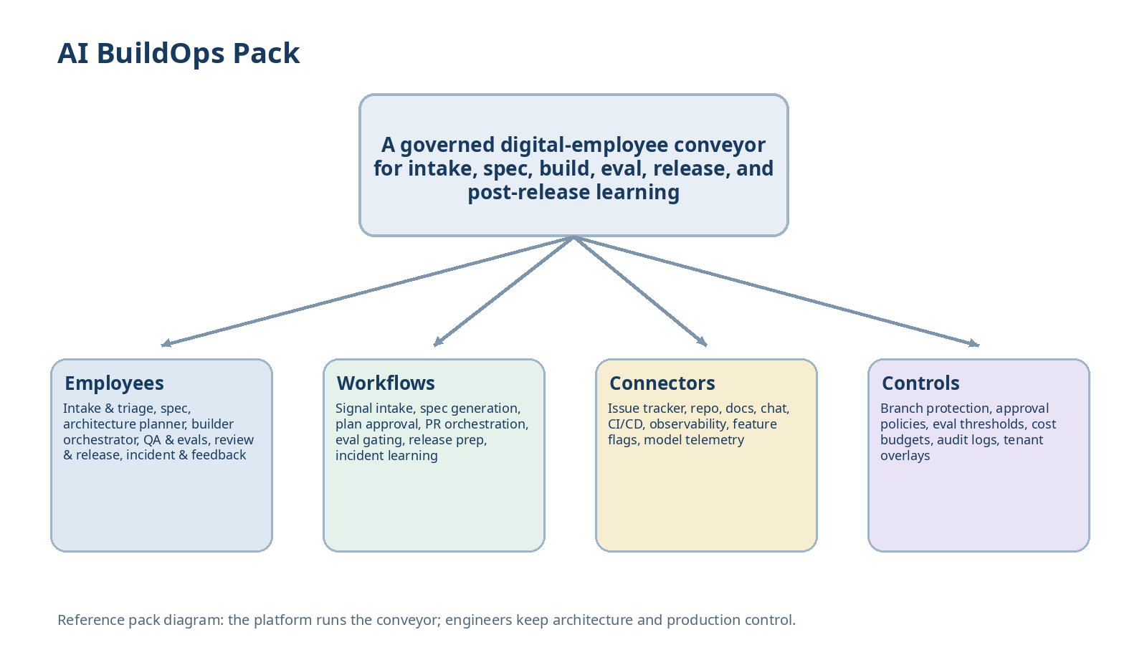
Figure 1. The AI BuildOps pack organizes digital employees around the common delivery conveyor used by AI product companies.
1. Purpose, scope, and design goals
The purpose of this pack is to make Ruh.ai useful beyond one industry by packaging a repeatable operating model for software teams, especially companies building AI-native products. The design assumption is that modern teams already have best-of-breed tools for code, tracking, documentation, CI, and observability, but lack one execution layer that can move work across those systems consistently.
The pack should reduce the coordination tax around software delivery without pretending that architecture judgment, code ownership, or production accountability can be fully delegated. Humans still decide what to build, what to merge, and what to ship; the digital employees remove repetitive assembly, analysis, and follow-through work around those decisions.
Must work across common combinations of GitHub or GitLab, Jira or Linear, Slack or Teams, Notion or Confluence, and major CI/observability vendors.
Must treat AI-specific quality gates as first-class: prompt changes, model-route changes, tool changes, and eval thresholds.
Must keep protected-branch merges, deployment, and customer-facing incident communication behind explicit approvals.
Must convert production failures and bad conversations into reusable regression cases.
1.1 Out of scope for V1
Fully autonomous production deploys, automatic merges to protected branches, or unsupervised architectural changes.
A replacement for the issue tracker, code host, docs system, or observability vendor.
Optimization for lines of code written; the pack is judged by delivery quality and throughput, not code volume.
2. Target operating model and deployment assumptions
Dimension | Reference assumption | Why it matters
Tenant boundary | One company or one clearly isolated business unit per deployment boundary | Matches the platform trust and secret model.
Workspace model | One workspace per product or repo cluster; optional portfolio workspace for leadership analytics | Keeps context and approvals scoped to the right codebase.
Primary operators | Engineering manager, PM, tech lead, engineer, QA lead, SRE, support lead | These roles review and benefit from the artifacts.
System of record | At least one issue tracker, one code host, one docs system, and one CI pipeline are already in place | The pack writes back into real delivery systems.
AI feature surface | The team ships prompts, model routes, agent workflows, or other AI behaviors that can regress independently of code | Needed to justify eval-first workflow design.
Rollout mode | Pilot one team and one product area before multi-team rollout | Required to tune policies, stacks, and cost budgets.

Supported customer archetypes
AI-native SaaS company shipping prompt, agent, or model-driven product features.
B2B product team with strong code tooling but weak workflow orchestration across product, engineering, QA, and ops.
Internal platform or applied-AI team that needs a governed delivery conveyor for multiple services.

3. Pack identity, dependency model, and exported assets
This is a function reference pack rather than a vendor-specific or industry-specific pack. It declares reusable workflow assets for product delivery and binds to provider adapters through overlay values.
Manifest field | Reference value
id | ref.ai.buildops
version | 1.0.0
packType | function-reference
dependsOn | ruh.foundation.runtime; ruh.foundation.approvals; ruh.foundation.code; provider overlays
exports.employeeTemplates | 7
exports.workflowTemplates | 7
defaultPolicyProfile | ai-buildops-default
defaultEvalSuite | ai-buildops-core

3.1 Suggested source tree
ai.buildops/
pack.yaml
README.md
employees/
intake-triage.yaml
spec-employee.yaml
architecture-planner.yaml
builder-orchestrator.yaml
qa-evals.yaml
review-release.yaml
incident-feedback.yaml
workflows/
signal-intake.yaml
spec-generation.yaml
architecture-plan.yaml
build-orchestration.yaml
eval-gating.yaml
release-prep.yaml
incident-learning.yaml
artifacts/
work-item-brief.schema.json
spec-package.schema.json
technical-plan.schema.json
eval-run-summary.schema.json
release-brief.schema.json
incident-rca.schema.json
skills/
repo-context/
coding-agent-control/
eval-ops/
release-prep/
incident-correlation/
evals/
triage/
spec-quality/
planner/
policy/
ai-regression/
overlays/
github-linear.overlay.yaml
github-jira.overlay.yaml
gitlab-jira.overlay.yaml

4. Canonical objects and delivery vocabulary
To stay horizontal, the pack normalizes the objects that matter across software delivery and AI feature iteration. Provider-specific IDs remain available in adapters, but workflow logic should use canonical objects.
Canonical object | Description | Representative source systems
Signal | Any raw inbound item such as support feedback, Slack thread, bug alert, or incident page. | Slack, email, support, observability
Work item | Normalized unit of work with owner, priority, linked evidence, and desired outcome. | Jira, Linear, internal graph
Spec package | Problem statement, user story, acceptance criteria, rollout notes, and risks. | Docs, issue tracker
Technical plan | Proposed implementation path including touched systems, files, migrations, and tests. | Docs, PR planning
Code change | Branch, commits, pull request, and linked CI runs. | GitHub, GitLab
Eval suite | AI and software checks that must pass for a change type. | Eval store, CI
Prompt/model route | Versioned AI behavior surface that may change independently of code. | Prompt registry, config repo
Release | Packaged change set, rollout plan, notes, and approvals. | CI/CD, release tooling
Incident | Production problem with customer or operational impact. | Sentry, Datadog, PagerDuty
Regression case | Test or eval derived from prior failure or bad conversation. | Eval store, test suite

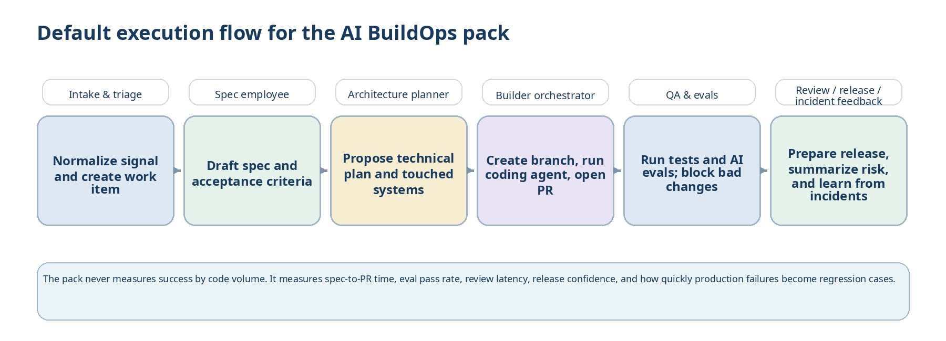
Figure 2. Default collaboration pattern for the AI BuildOps conveyor: a work item flows from intake through spec, planning, build, eval, release, and feedback.
5. Employee roster and collaboration contract
The pack exports seven default employees. Each employee has one primary responsibility and a narrow capability set. Collaboration happens through official workflow tasks and artifacts, never through hidden side channels.
Employee | Primary lane | Default risk tier | What success looks like
Intake & triage | Normalize inbound signal and create a clean work item | Low | Important signals are deduplicated, prioritized, and assigned fast.
Spec employee | Turn ambiguous requests into a usable spec package | Low | Teams start with clearer requirements and acceptance criteria.
Architecture planner | Propose implementation plan and touched systems | Low-Medium | Humans review better first-pass technical plans.
Builder orchestrator | Coordinate coding agents, branches, and PR creation | Medium | Changes arrive as reviewable PRs with context attached.
QA & evals | Run tests, generate regression cases, and block risky changes | Medium | AI and code regressions are caught before release.
Review & release | Prepare release artifacts, rollout notes, and enablement summaries | Medium | Release prep is faster and more consistent.
Incident & feedback | Correlate incidents, summarize RCA, and feed failures back into evals | Medium | Production issues create learning loops instead of one-off cleanup.

5.1 Intake & triage
Field | Definition
Purpose | Normalizes fragmented inputs across product, support, engineering, and operations into typed work items with evidence links and severity hints.
Primary triggers | Slack thread; support ticket; observability alert; product request; manually submitted work request.
Accepts tasks | signal.normalize; work-item.create; duplicate.cluster
Produces | Work-item brief; source bundle; severity recommendation; owner/team suggestion.
Capabilities | messaging.read; issue.read/write; docs.search; observability.read; task.write-internal
Default approval profile | Auto for internal work-item creation and routing. External responses remain human-controlled.
Key KPIs | Time-to-owner; duplicate rate; triage precision.

5.2 Spec employee
Field | Definition
Purpose | Turns messy requirements into a specification package that engineering and product can review before implementation starts.
Primary triggers | Approved work item; PM request; support escalation needing a product fix.
Accepts tasks | spec.generate; acceptance-criteria.expand; rollout-notes.prepare
Produces | Spec package; open questions; risk notes; rollout checklist draft.
Capabilities | docs.read/write-draft; issue.read/write-draft; messaging.draft
Default approval profile | Human review required before the spec becomes the official implementation target.
Key KPIs | Spec completeness; review acceptance; rework reduction.

5.3 Architecture planner
Field | Definition
Purpose | Produces a first-pass technical plan from the codebase, docs, and recent incidents so humans start from a stronger design baseline.
Primary triggers | Approved spec package; incident follow-up; change request touching multiple systems.
Accepts tasks | plan.generate; touched-systems.predict; migration-risk.assess
Produces | Technical plan; touched services/files; migration and dependency risks; test strategy draft.
Capabilities | repo.read; docs.read; search.index.read; issue.write-draft
Default approval profile | Plan approval required before a builder workflow starts on medium or high-risk changes.
Key KPIs | Plan acceptance; file-touch prediction quality; review churn reduction.

5.4 Builder orchestrator
Field | Definition
Purpose | Coordinates the mechanical execution steps around implementation by creating the right branch, invoking the right coding agent, opening the PR, and attaching context back to the work item.
Primary triggers | Approved technical plan; approved small change request; follow-up fix from eval failure.
Accepts tasks | build.start; branch.create; coding-agent.invoke; pr.open
Produces | Branch; pull request; linked CI run; implementation summary; follow-up tasks.
Capabilities | repo.read/write-limited; issue.update; ci.trigger; coding-agent.control
Default approval profile | No direct merge or protected-branch write. PR creation may be automated under policy.
Key KPIs | Spec-to-PR time; PR completeness; failure-to-retry handling.

5.5 QA & evals
Field | Definition
Purpose | Makes quality gates explicit for both classical software behavior and AI behavior by turning failures into tests and blocking risky changes before release.
Primary triggers | New PR; prompt/model/tool change; incident follow-up; bad production conversation.
Accepts tasks | test.run; eval.run; regression-case.generate; gate.decision
Produces | Eval run summary; regression bundle; blocked-change rationale; quality dashboard update.
Capabilities | ci.trigger; eval.store.read/write; repo.read; model-config.read
Default approval profile | Auto for eval execution. Any gate override requires human approval and is fully logged.
Key KPIs | Eval pass rate; escaped-regression reduction; regression-case growth.

5.6 Review & release
Field | Definition
Purpose | Packages approved changes into clear release artifacts, rollout notes, and internal enablement summaries.
Primary triggers | PR approved; release window reached; feature-flag change ready.
Accepts tasks | release.prepare; changelog.compose; rollout-checklist.generate
Produces | Release brief; changelog; customer/internal summary; rollout checklist.
Capabilities | repo.read; ci.read; docs.write-draft; messaging.draft; feature-flag.read
Default approval profile | Production deploy and external customer communication require explicit approval.
Key KPIs | Release prep time; change-summary quality; rollback readiness.

5.7 Incident & feedback
Field | Definition
Purpose | Closes the learning loop by correlating incidents, recent changes, and user feedback, then converting real failures into new tasks, tests, and evals.
Primary triggers | Incident created; postmortem request; repeated support complaint; eval miss in production.
Accepts tasks | incident.summarize; rca.draft; regression-case.backfill
Produces | Incident summary; RCA draft; linked code-change evidence; new regression cases; follow-up work items.
Capabilities | observability.read; repo.read; issue.write-draft; eval.store.write; docs.write-draft
Default approval profile | External incident communication stays human-owned. Internal RCA and follow-up drafts may auto-generate.
Key KPIs | Incident-to-RCA time; evidence-link quality; production-failure-to-regression conversion rate.

6. Workflow catalog
The reference pack organizes work as a conveyor. Each workflow is reusable pack content that can be composed into a tenant-specific operating model through overlays and policy settings.
Workflow | Primary trigger | Employee pattern | What the workflow does | Approval gate | Primary measures
Signal intake and triage | Incoming request, alert, or thread | Intake & triage | Cluster duplicates, link evidence, create work item, propose owner and priority | Usually auto | Time-to-owner; triage precision
Spec generation | Approved work item | Spec employee | Draft problem statement, acceptance criteria, rollout notes, and open questions | Spec review required | Spec acceptance; rework reduction
Architecture planning | Approved spec | Architecture planner | Propose touched systems, implementation path, migrations, and test plan | Plan approval for medium/high risk | Plan acceptance; review churn
Build orchestration | Approved technical plan | Builder orchestrator | Create branch, invoke coding agent, open PR, link CI and work item | No direct merge | Spec-to-PR time; PR completeness
Eval gating | New PR or AI behavior change | QA & evals | Run tests, generate regression cases, compare prompt/model variants, block bad changes | Gate overrides require approval | Eval pass rate; escaped regressions
Release preparation | PR approved and ready to ship | Review & release | Assemble release brief, rollout checklist, summaries, and deployment metadata | Deploy approval required | Release prep time; rollback readiness
Incident learning | Incident or repeated failure | Incident & feedback | Draft RCA, link recent changes, create regression cases, open follow-up work items | External comms require approval | Incident-to-RCA time; learning-loop closure

6.1 MVP workflow slice
Start with intake, spec generation, build orchestration, QA/evals, and release prep on one product team.
Keep architecture planner in the MVP for non-trivial changes because it creates the context boundary for builder workflows.
Bring incident & feedback online after the first shipping loop so real failures can generate regression cases.
7. Connector and capability profile
The pack binds to normal software-delivery capabilities rather than hardcoding one vendor stack. A tenant overlay chooses the actual providers and approval rules.
Capability group | Required? | Typical providers | Pack usage
issue.read/write | Yes | Jira; Linear | Create and update work items, specs, and follow-up tasks.
repo.read/write-limited | Yes | GitHub; GitLab | Read code context, create branches, and open PRs under policy.
docs.read/write-draft | Yes | Notion; Confluence; Google Docs; internal docs | Draft spec packages, plans, release notes, and RCAs.
messaging.read/draft | Yes | Slack; Teams; email | Capture inbound signals and prepare summaries or internal notifications.
ci.trigger/read | Yes | GitHub Actions; GitLab CI; Buildkite | Run tests, evals, and collect build status.
observability.read | Recommended | Sentry; Datadog; New Relic; PagerDuty | Enrich triage, RCA, and release decisions.
eval.store.read/write | Yes | Internal eval registry; vendor eval tooling | Store regression cases and gate rules.
feature-flag.read | Optional | LaunchDarkly; Statsig; internal config | Prepare rollout plans and blast-radius checks.
model-config.read | Recommended | Prompt registry; config repo; gateway config | Track prompt/model route changes and required evals.

7.1 Minimum provider overlays
providers:
issueTracker:
adapter: linear | jira
repo:
adapter: github | gitlab
docs:
adapter: notion | confluence | gdocs
messaging:
teamChat: slack | teams
ci:
adapter: github-actions | gitlab-ci | buildkite
observability:
adapter: sentry | datadog | new-relic
policies:
protectedBranches:
- main
- release/*
requireHumanMerge: true
requireHumanDeploy: true
evalGateProfile: strict

8. Policy, approval, and safety model
The delivery conveyor becomes dangerous when automation can silently merge, deploy, or change protected configuration. The default policy profile therefore makes branch protection, eval gates, and deployment approvals explicit.
Representative action | Default treatment | Notes
Create internal work item or draft spec | Auto | Low-risk internal artifact creation.
Generate technical plan | Auto draft | Human review expected before medium/high-risk changes proceed.
Create branch, invoke coding agent, open PR | Auto under policy | Only for allowed repos/paths; no protected-branch writes.
Merge PR to protected branch | Approval required | Human-only in V1 unless explicitly overridden later.
Run tests and AI evals | Auto | Core control surface of the pack.
Override a failed eval gate | Approval required | Requires named approver and logged rationale.
Deploy to staging | Approval required or tenant policy | Allowed only where tenant enables it.
Deploy to production | Human only | Not automated in V1.
Send customer-facing incident update | Approval required | External communication remains human-owned.
Change secrets, credentials, or protected configs | Human only | Out of scope for unattended automation.

Approval rule design principle
The pack should automate assembly, comparison, and workflow progression early. It should not automate irreversible or high-blast-radius actions until the customer has operational confidence, eval maturity, and explicit approval design.

9. Canonical artifacts and sample contracts
All collaboration between employees and humans should pass through structured artifacts that can be stored, reviewed, versioned, and replayed. This is especially important for AI behavior changes, where the artifact is what makes the work auditable.
Artifact | Produced by | Required fields
Work-item brief | Intake & triage | signalRefs; classification; proposedOwner; severity; evidenceLinks; duplicateCluster
Spec package | Spec employee | problem; desiredOutcome; acceptanceCriteria; rolloutNotes; openQuestions
Technical plan | Architecture planner | touchedSystems; touchedFiles; migrationRisk; testStrategy; dependencies
Build summary | Builder orchestrator | branch; PRRef; codingAgentRunRefs; CIRefs; unresolvedItems
Eval run summary | QA & evals | changeType; suitesRun; passFail; criticalFindings; overrideRequired
Release brief | Review & release | changes; flags; rolloutPlan; rollbackPlan; approvals
Incident RCA | Incident & feedback | timeline; suspectedCause; evidence; relatedChanges; followUps
Regression case bundle | QA & evals / incident & feedback | testCases; evalCases; sourceFailureRefs; expectedBehavior

9.1 Sample workflow input
task:
type: spec.generate
workspaceRef: product:copilot-assistant
sourceRefs:
- slack:thread:4419
- support:ticket:8931
- issue:BUG-204
requester:
personRef: user:pm-17
context:
productArea: "conversation memory"
severity: medium
linkedIncident: INC-33

9.2 Sample eval run summary
artifact:
type: eval-run-summary
changeType: prompt-and-tooling
suitesRun:
- regression:conversation-memory
- safety:prompt-injection
- latency:assistant-core
result: fail
criticalFindings:
- "Memory recall regression on 3 of 40 gold cases"
overrideRequired: true
followUpTasks:
- issue:ENG-1172

10. Eval suite and release gates
A reference pack for AI product companies is only reusable if it can be validated repeatedly. The pack therefore ships eval families that test work-item quality, plan quality, AI regression coverage, policy enforcement, and release readiness.
Eval family | What it checks | Suggested release threshold
Triage evals | Correct work-item classification, deduplication, and routing | >= 0.90 weighted accuracy
Spec quality evals | Completeness of acceptance criteria, rollout notes, and open questions | >= 0.85 reviewer acceptance
Planner evals | Reasonable touched-system prediction and risk surfacing | >= 0.80 acceptance on reference set
Build-policy evals | No protected-branch writes, proper PR linkage, safe retries | 100% pass on policy tests
AI regression evals | Prompt/model/tool behavior against gold sets and prior failures | No critical failures on required suites
Release readiness evals | Presence of rollback plan, approvals, and deployment metadata | 100% on required checklist items
Incident learning evals | Quality of evidence linking and conversion to regression cases | >= 0.85 reviewer acceptance

Any change that touches prompts, model routes, agent tools, or safety policies must map to an eval gate profile before release.
Gate overrides require a named approver and a recorded reason.
Every escaped production failure should create either a new test, a new eval case, or a policy rule update.
11. MVP deployment plan for the reference pack
Phase | What ships | Definition of success
Phase 1 - operating spine | Workspace setup, issue/repo/docs/chat connectors, intake & triage, spec employee | Requests arrive as clean work items with usable draft specs.
Phase 2 - execution loop | Architecture planner, builder orchestrator, PR linkage, CI hooks | Approved work regularly turns into reviewable PRs with context attached.
Phase 3 - quality gates | QA & evals, eval registry, regression generation, approval UX | Risky changes are blocked before release and failures create reusable evals.
Phase 4 - release and learning | Review & release, incident & feedback, dashboarding, overlay hardening | Release prep shrinks and production failures feed the conveyor.

Pilot success metrics
Reduction in time from signal arrival to an owned, reviewable work item.
Reduction in spec-to-PR cycle time for approved work.
Increase in eval coverage for AI behavior changes.
Reduction in escaped regressions and faster incident-to-RCA turnaround.

12. Example manifest and overlay excerpts
12.1 Manifest excerpt
id: ref.ai.buildops
version: 1.0.0
packType: function-reference
dependsOn:
- ruh.foundation.runtime@^1.0
- ruh.foundation.approvals@^1.0
- ruh.foundation.code@^1.0
exports:
employeeTemplates:
- buildops.intake-triage.v1
- buildops.spec-employee.v1
- buildops.architecture-planner.v1
- buildops.builder-orchestrator.v1
- buildops.qa-evals.v1
- buildops.review-release.v1
- buildops.incident-feedback.v1
workflowTemplates:
- buildops.signal-intake.v1
- buildops.spec-generation.v1
- buildops.architecture-plan.v1
- buildops.build-orchestration.v1
- buildops.eval-gating.v1
- buildops.release-prep.v1
- buildops.incident-learning.v1
defaultPolicyProfile: ai-buildops-default
defaultEvalSuite: ai-buildops-core

12.2 Tenant overlay excerpt
tenant:
name: "Sample AI Product Co"
workspaceMode: per-product
providers:
issueTracker:
adapter: linear
repo:
adapter: github
docs:
adapter: notion
messaging:
teamChat: slack
ci:
adapter: github-actions
observability:
adapter: sentry
policies:
protectedBranches:
- main
- release/*
requireHumanMerge: true
requireHumanDeploy: true
evalGateProfile: strict
codingAgentAllowedPaths:
- services/assistant
- prompts/

Appendix A. Runtime mapping example
Exported employee | Compiled OpenClaw agent id | Workspace bootstrap files | Primary skill groups
buildops.intake-triage.v1 | prod-<id>-triage | SOUL.md; AGENTS.md; intake-playbook.md | signal-triage; issue-routing
buildops.spec-employee.v1 | prod-<id>-spec | SOUL.md; AGENTS.md; spec-playbook.md | spec-authoring; rollout-notes
buildops.architecture-planner.v1 | prod-<id>-planner | SOUL.md; AGENTS.md; planning-playbook.md | repo-context; plan-generation
buildops.builder-orchestrator.v1 | prod-<id>-builder | SOUL.md; AGENTS.md; build-playbook.md | coding-agent-control; pr-orchestration
buildops.qa-evals.v1 | prod-<id>-evals | SOUL.md; AGENTS.md; eval-playbook.md | eval-ops; regression-generation
buildops.review-release.v1 | prod-<id>-release | SOUL.md; AGENTS.md; release-playbook.md | release-prep; changelog
buildops.incident-feedback.v1 | prod-<id>-incident | SOUL.md; AGENTS.md; incident-playbook.md | incident-correlation; rca-drafting

Appendix B. Source assumptions
The references below anchor the OpenClaw runtime assumptions used by this reference pack and should be revisited whenever the runtime adapter changes.
[R1] OpenClaw CLI - agents (isolated agents with workspaces, auth, and routing) - https://docs.openclaw.ai/cli/agents
[R2] OpenClaw tools - skills (AgentSkills-compatible skill folders) - https://docs.openclaw.ai/tools/skills
[R3] OpenClaw automation - hooks - https://docs.openclaw.ai/automation/hooks
[R4] OpenClaw automation - cron jobs - https://docs.openclaw.ai/automation/cron-jobs
[R5] OpenClaw gateway - sandboxing - https://docs.openclaw.ai/gateway/sandboxing
[R6] OpenClaw gateway - security - https://docs.openclaw.ai/gateway/security

